Created IAM users and assigned AdministratorAccess and PowerUserAccess policies to manage AWS resources and permissions.
1.Creating IAM user “Jane” from root account with AdministratorAccess.
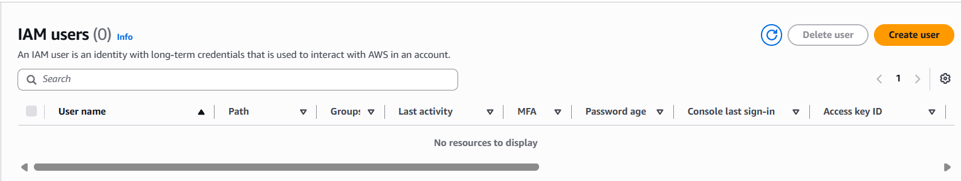
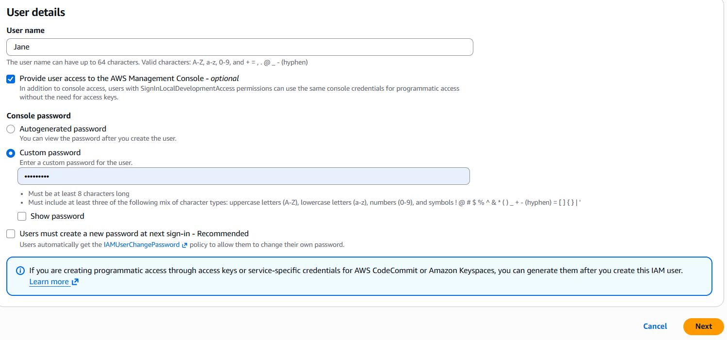
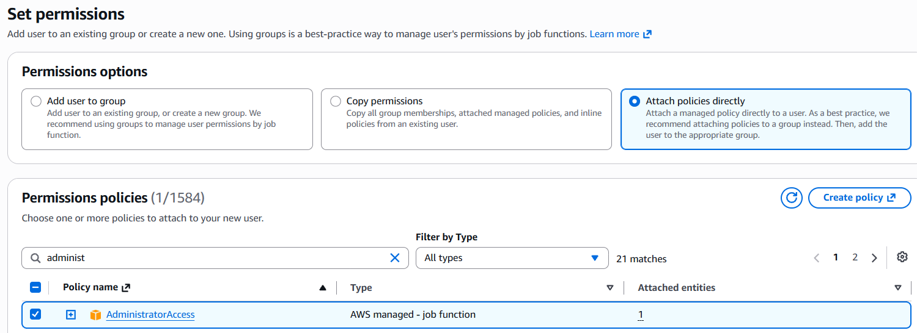
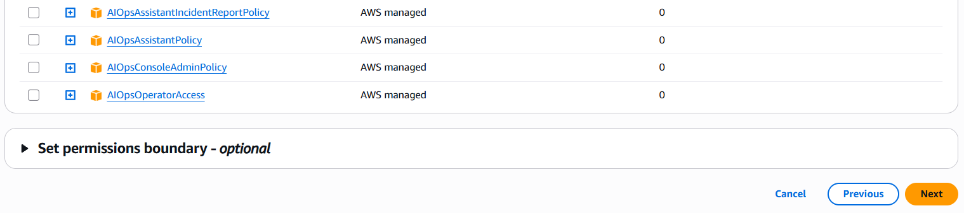
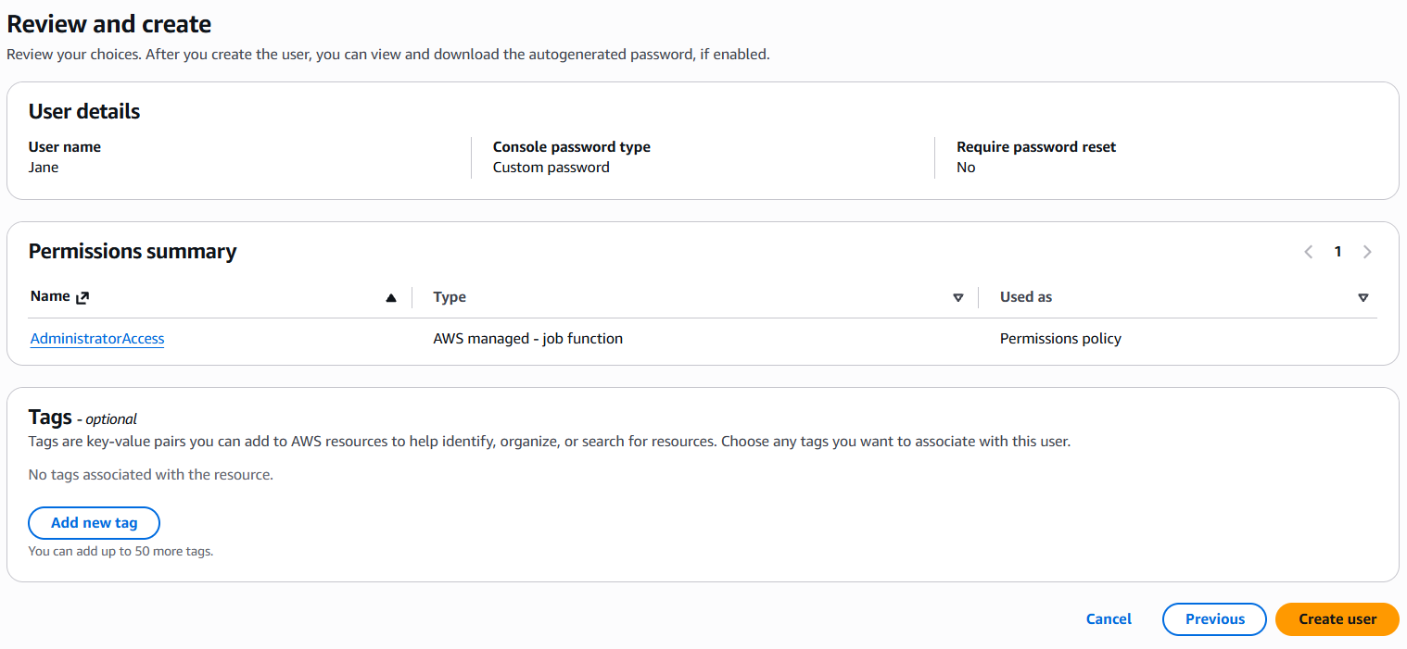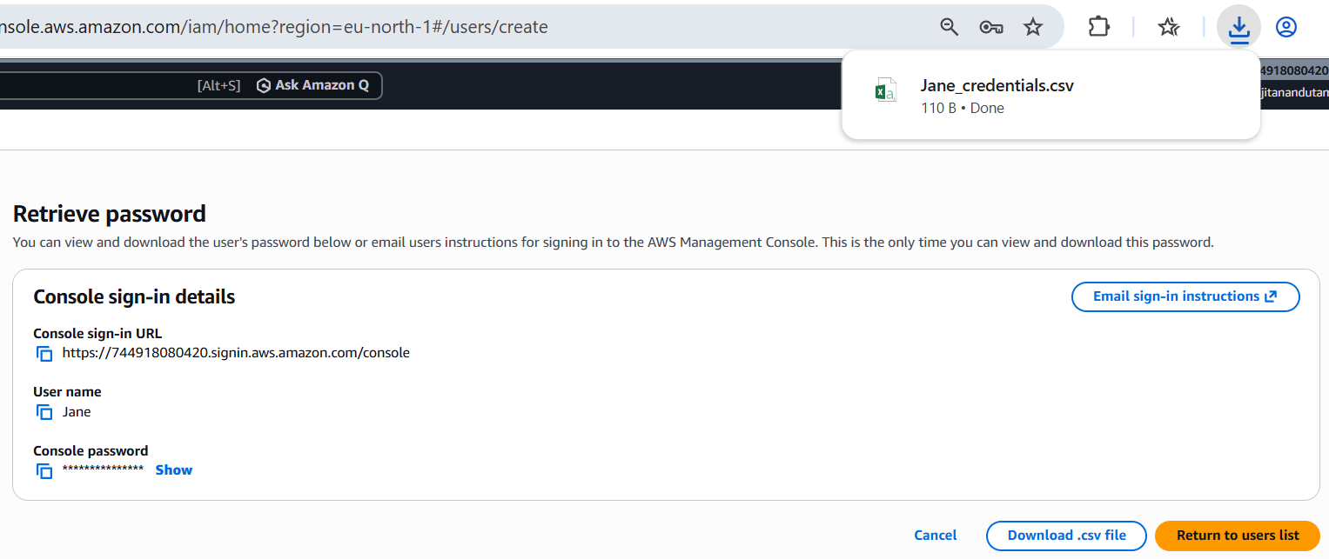
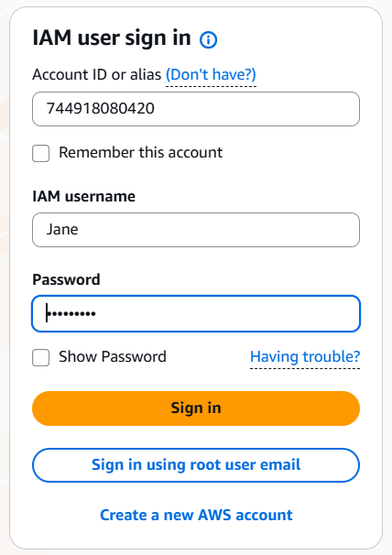
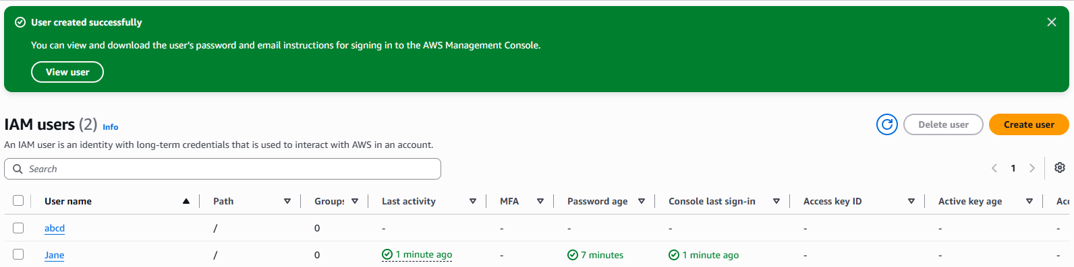
New user created “abcd” successfully.
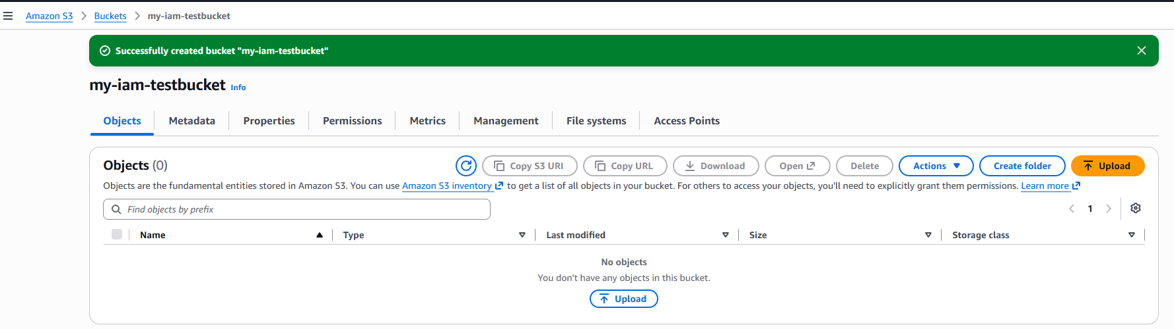
“my-iam-testbucket” created successfully in S3.
2.Creating IAM user “Susan” from root account with PowerUserAccess.
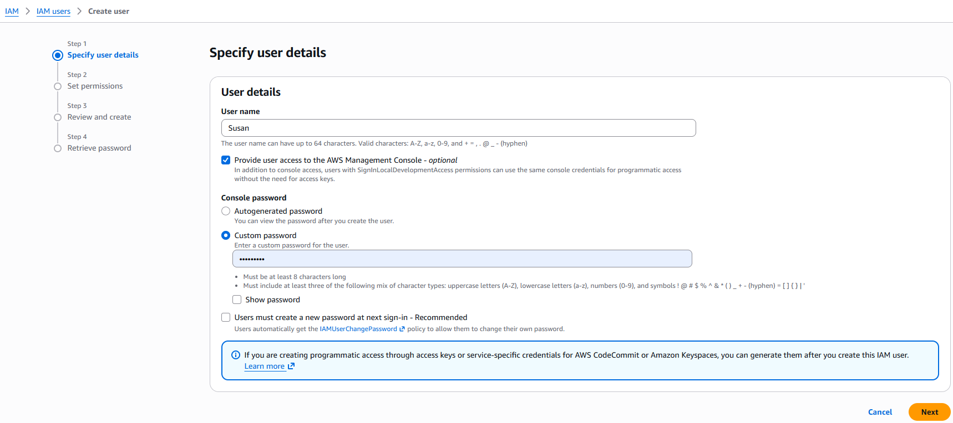
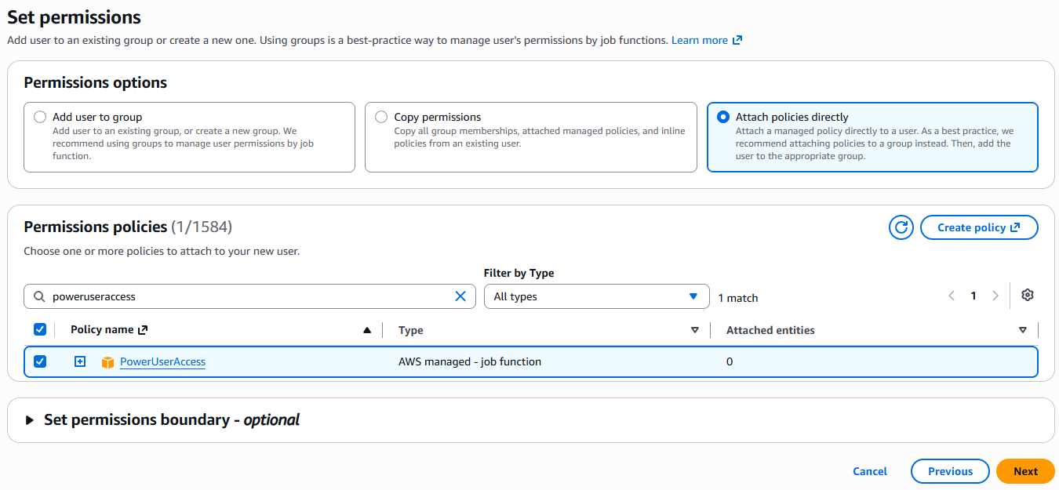
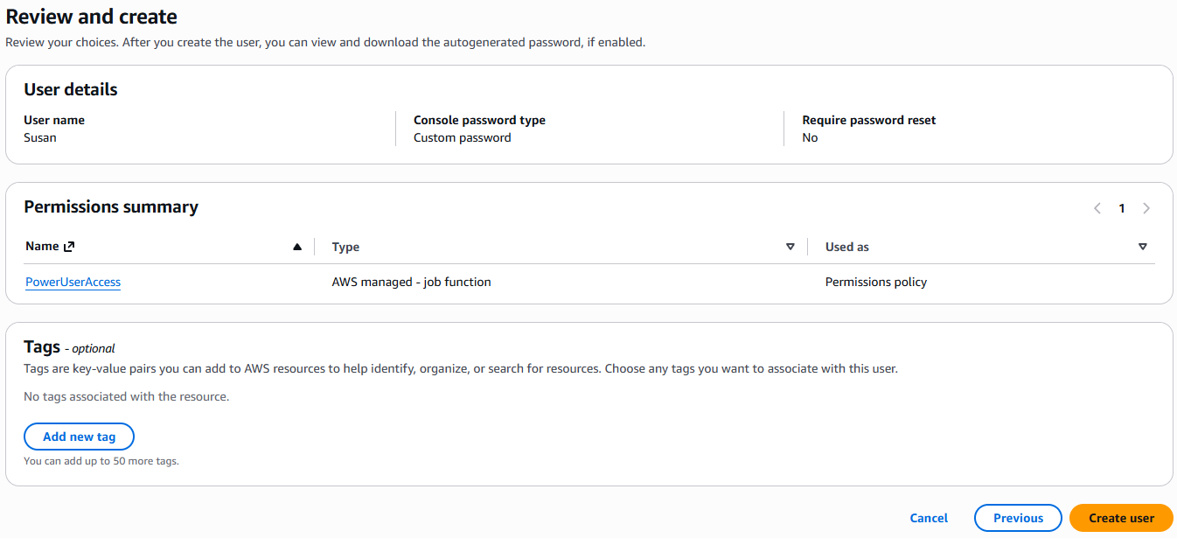
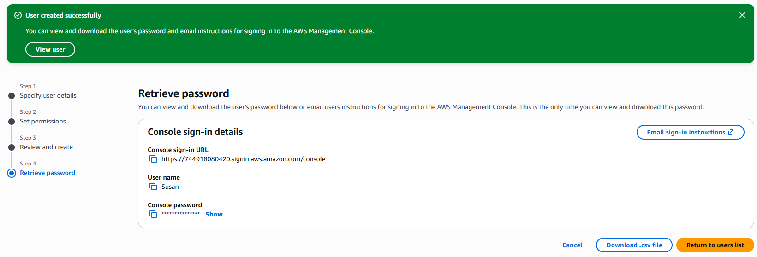
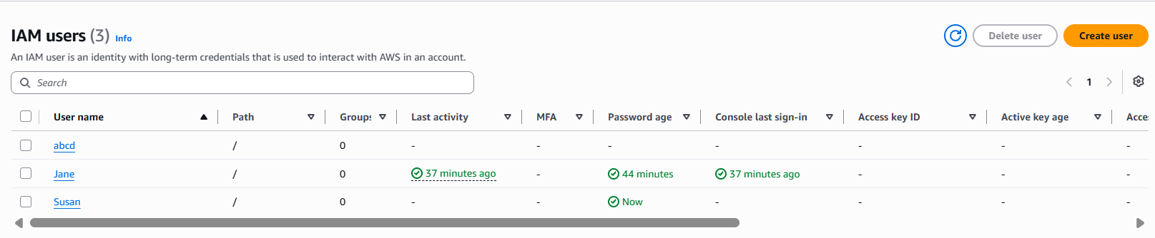
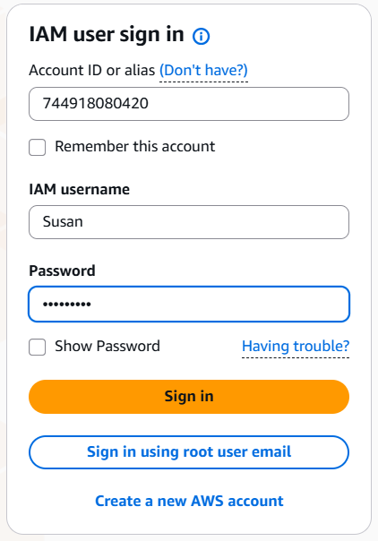s
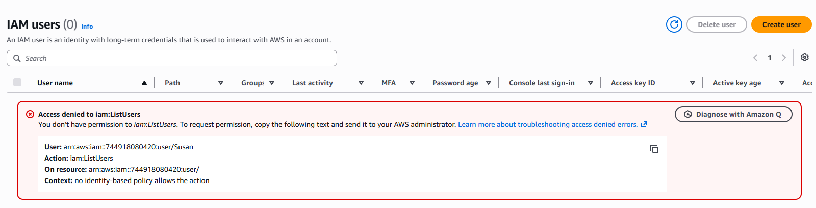
Unable to create a new IAM user due to the permission restrictions associated with the PowerUserAccess policy attached to the existing IAM user - Susan.
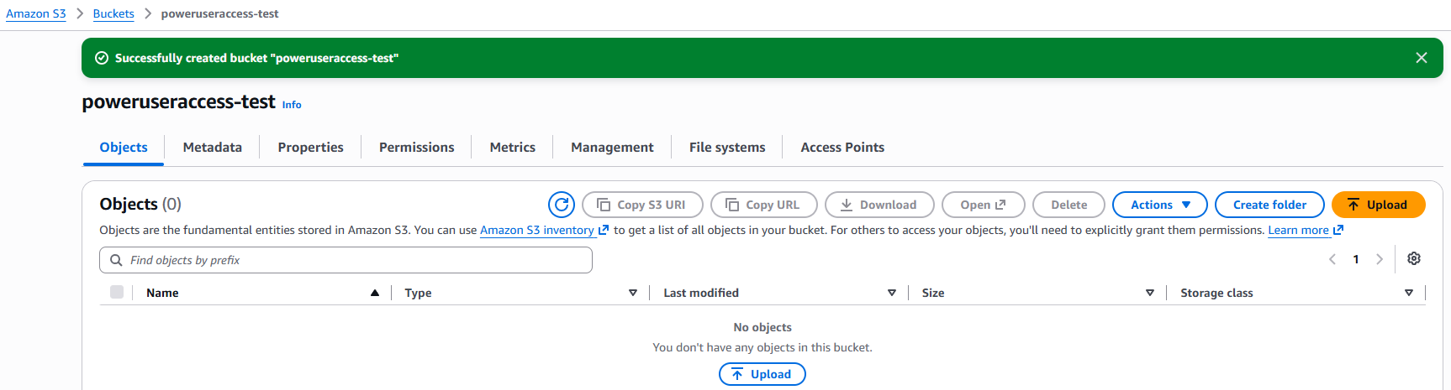
“poweruseraccess-test” created successfully in S3.

